**Project 2 – Telling a Story With Data**

Jessica Borgos, Thom Brekke, Jeffrey Lindow

The Proposal

For this project we’ll explore the change in housing prices across a geographical area – in this case we’re beginning with the Bay Area, but, if we have time, will scale this up to California, the West Coast, or even the entire country. We will represent the changes in the market on a map, showing the most and least expensive areas and the changes to those areas real home prices over time. Specific visualizations we’re considering include a heatmap of most popular housing markets based on price, number of homes sold, number of rentals, a choropleth showing the most and least expensive areas in the area relative to one another, the relative change in home prices year over year (potentially compared to an indicator like the CPI or the Dow Jones Industrial Average), to name a few possibilities. We’re also interested in comparing housing prices to local ordinances, for example examining whether local minimum wage ordinances are in any way related to average home price or rent.

**The story we hope to find in the data** is the relationship between the relative strength of the economy, the price of homes in specific areas, and the relationship between one areas boom and another’s bust.

The Dataset

Our primary dataset comes from Zillow – the datasets we’re from selecting from are available here: <https://github.com/tcbrekke/project-2/tree/master/Resources>

Inspiration

<http://apps.urban.org/features/mortgages-by-race/#>

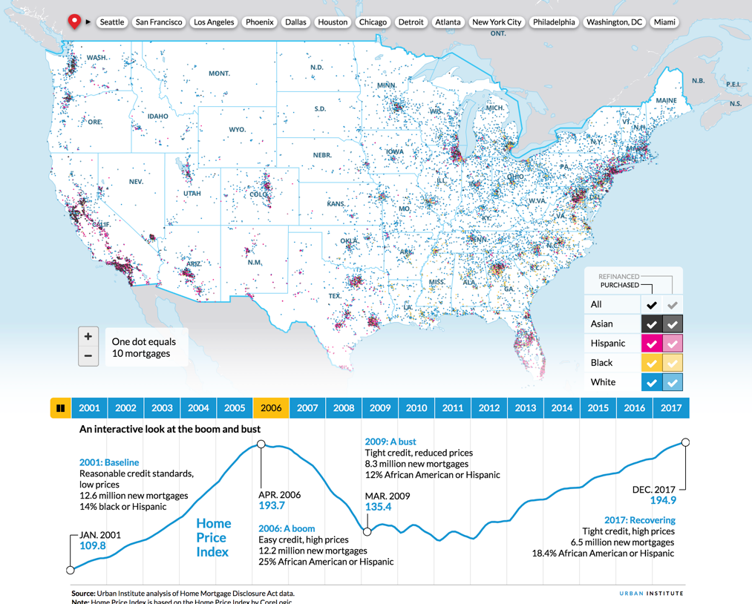

<http://grow.london/map-london/house-prices/>

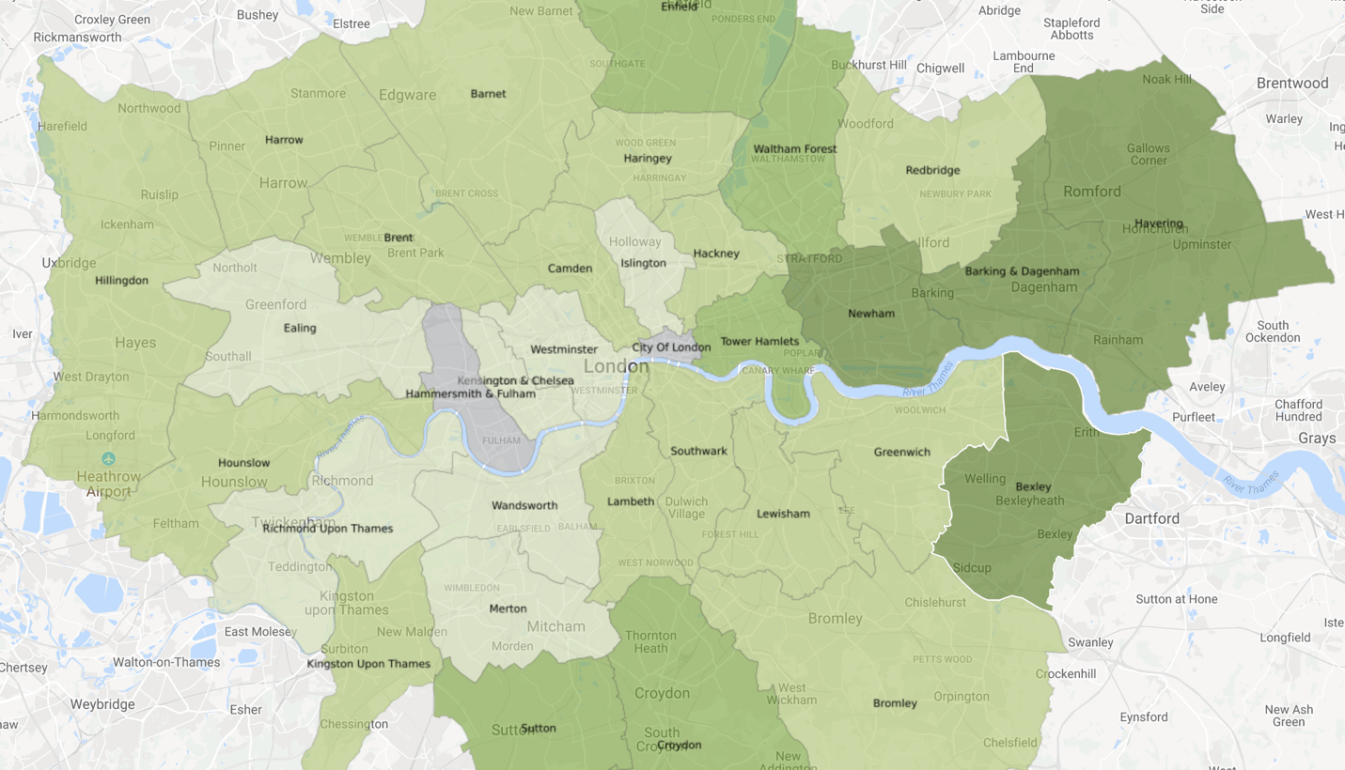

<https://www.trulia.com/real_estate/San_Francisco-California/>

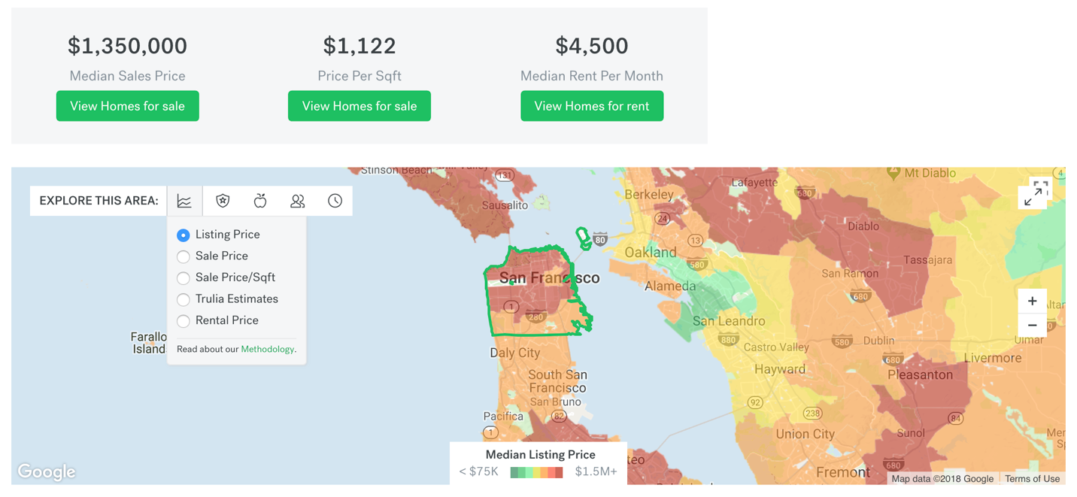

GitHub Link

<https://github.com/tcbrekke/project-2/tree/master>